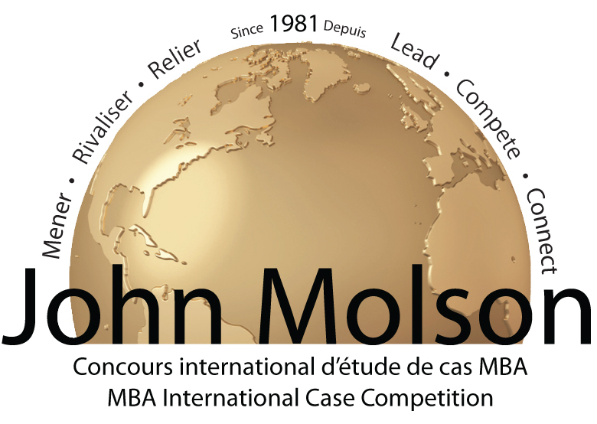

2013 John Molson MBA International Case Competition
Credit Card Authorization Form

Please print this page, and once completed:
Scan it and email to Kartik Rao at kartik.rao@mbacasecomp.com

If you have any questions, please call Kartik Rao at (514) 848-2424 ext. 2736.

I, of
Cardholder’s Name (please print legibly) University’s Name (please print legibly)

authorize the John Molson MBA International Case Competition of Concordia University to debit my credit card for the amount of $ Canadian.

Please select the type of credit card: VISA MASTERCARD

Credit Card #:

Expiration Date:

Signature Date

